***C++ LAB TASK-1 WITH SOLUTIONS***

1) Write a C++ program to print 'Hello' on screen and then print your name on a separate line.

#include<iostream>

using namespace std;

class disp

{

public:

char a[50]="Hello";

char b[50]="Kishore Kumar";

};

int main()

{

disp d1;

cout<<d1.a<<endl;

cout<<d1.b<<endl;

return 0;

}

Output:

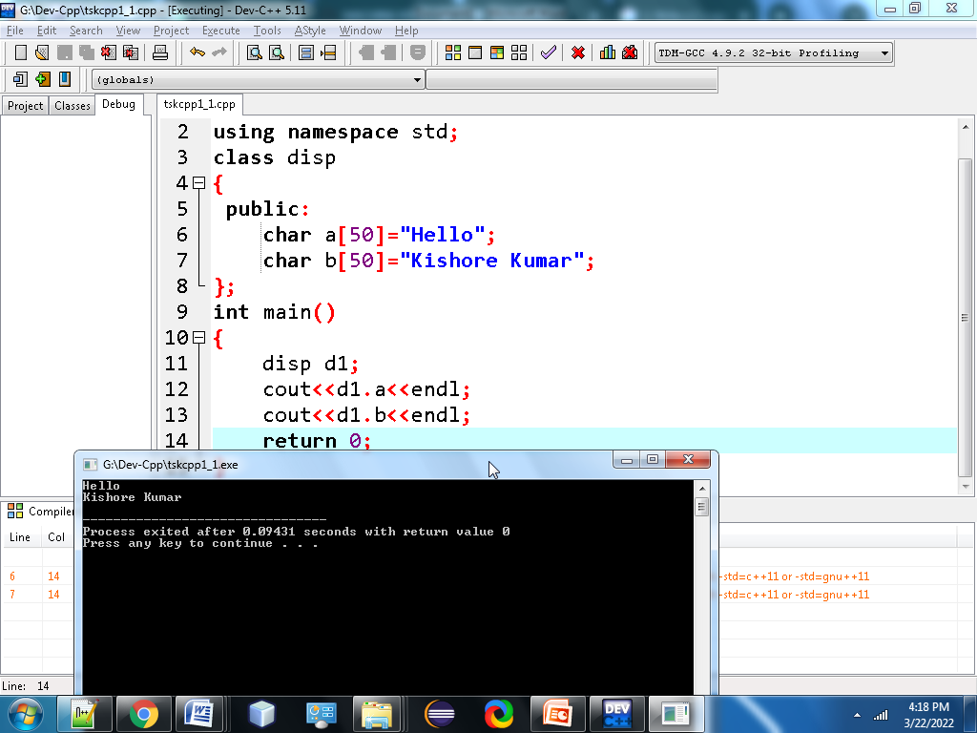

2. Write a C++ program to print the sum of two numbers.

**#include<iostream>**

**using namespace std;**

**class sum**

**{**

**public:**

**int a=80;**

**int b=8;**

**int c=a+b;**

**};**

**int main()**

**{**

**sum s1;**

**cout<<"The Value of A is:"<<s1.a<<endl;**

**cout<<"The Value of B is:"<<s1.b<<endl;**

**cout<<"The Sum of A and B is:"<<s1.c<<endl;**

**return 0;**

**}**

**Output:** 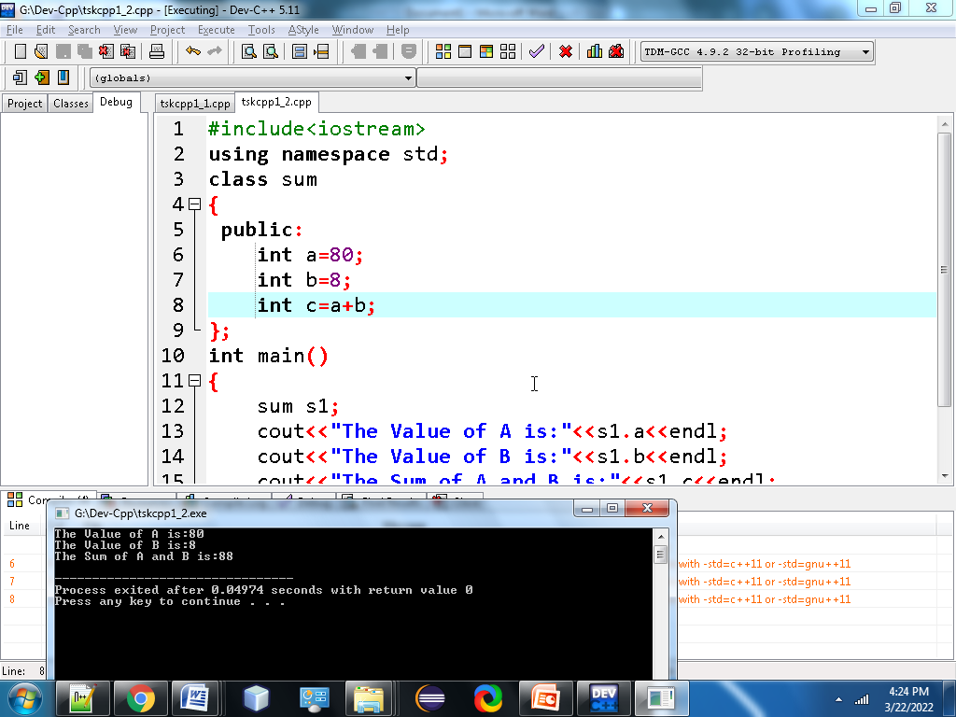

**3. Write a C++ program to print the result of the following operations?**

**#include<iostream>**

**using namespace std;**

**class sum**

**{**

**public:**

**int a=21;**

**int b=7;**

**};**

**int main()**

**{**

**sum s1;**

**cout<<"The Result of Addition is:"<<s1.a+s1.b<<endl;**

**cout<<"The Result of Subtraction is:"<<s1.a-s1.b<<endl;**

**cout<<"The Result of Multiplication is:"<<s1.a*s1.b<<endl;**

**return 0;**

**}**

**Output:** 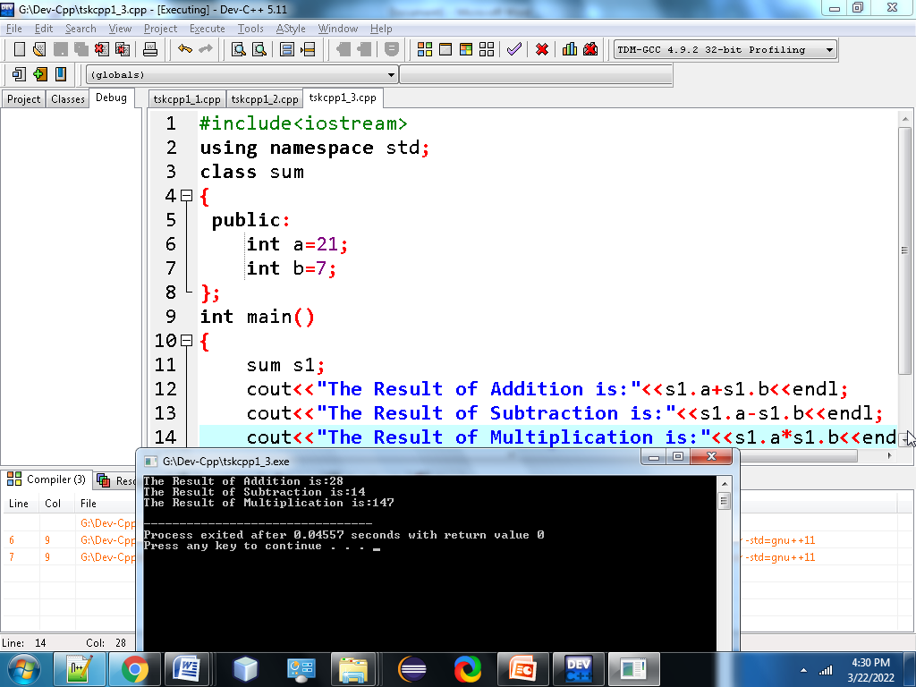

**4.Write a C++ program that takes two numbers as input and display the product of two numbers?**

**#include<iostream>**

**using namespace std;**

**class product**

**{**

**public:**

**int a;**

**int b;**

**};**

**int main()**

**{**

**product p1;**

**cout<<"Enter The Value of A is:";**

**cin>>p1.a;**

**cout<<"Enter The Value of B is:";**

**cin>>p1.b;**

**cout<<"The Product of two Number is:"<<p1.a*p1.b;**

**return 0;**

**}**

**Output:**

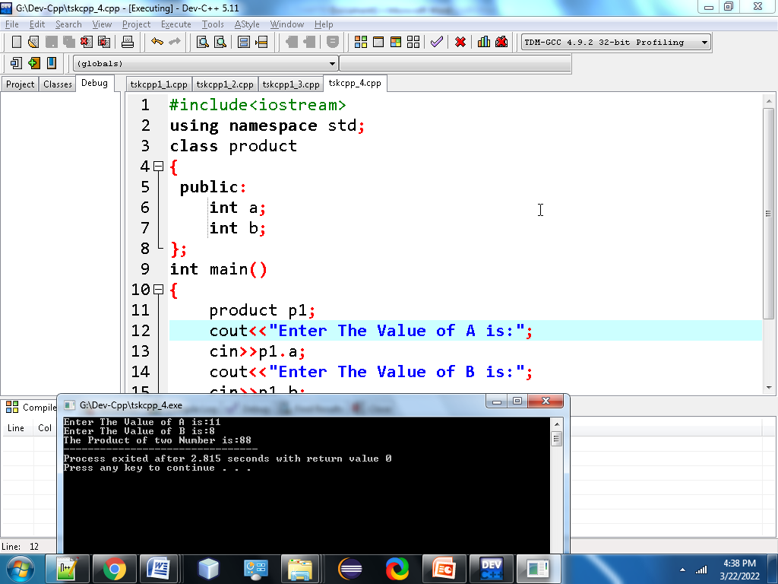

**5. Write a C++ program to print the sum (addition), multiply, subtract, divide and remainder of two numbers?**

**#include<iostream>**

**using namespace std;**

**class product**

**{**

**public:**

**int r;**

**int s;**

**};**

**int main()**

**{**

**product p1;**

**cout<<"Enter The Value of R is:";**

**cin>>p1.r;**

**cout<<"Enter The Value of S is:";**

**cin>>p1.s;**

**cout<<"The Sum of two Number is:"<<p1.r+p1.s<<endl;**

**cout<<"The Difference of two Number is:"<<p1.r-p1.s<<endl;**

**cout<<"The Product of two Number is:"<<p1.r*p1.s<<endl;**

**cout<<"The Divide of two Number is:"<<p1.r/p1.s<<endl;**

**cout<<"The Modulus of two Number is:"<<p1.r%p1.s<<endl;**

**return 0;**

**}**

**Output:** 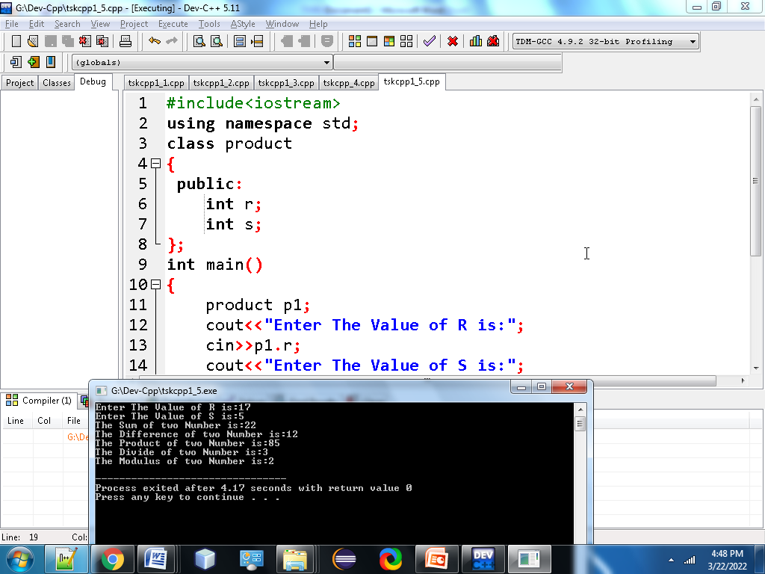

**6. Write a C++ program that takes a number as input and prints its multiplication table upto 10?**

**#include <iostream>**

**using namespace std;**

**class multi**

**{**

**public:**

**int n;**

**int i;**

**};**

**int main()**

**{**

**multi m1;**

**cout<<"Enter an integer:";**

**cin>>m1.n;**

**for (m1.i = 1; m1.i <= 10; ++m1.i) {**

**cout<<m1.n<<"*"<<m1.i<<"="<< m1.n *m1.i<<endl;**

**}**

**return 0;**

**}**

**Output:** 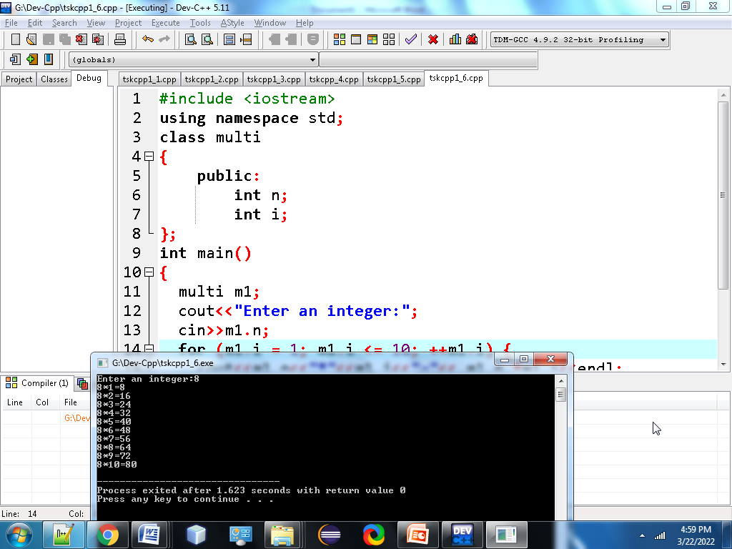

**7.Quest ion No 7 is Missing in the Given Lab Task**

**8. Write a C++ program to compute the specified expressions and print the output?**

**#include <iostream>**

**using namespace std;**

**class expr**

**{**

**public:**

**float c=(25.5 * 3.5 - 3.5 * 3.5) / (40.5 - 4.5);**

**};**

**int main()**

**{**

**expr e1;**

**cout <<"The Result of Expression is:"<<e1.c;**

**return 0;**

**}**

**Output:**

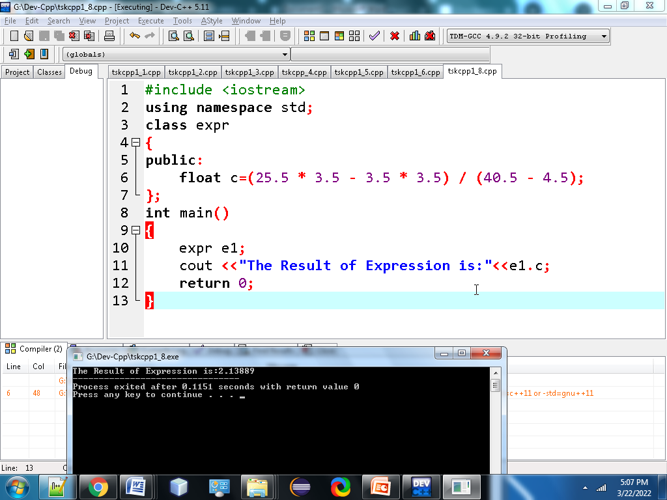

**9.Write a C++ program to print the area and perimeter of a circle?**

**#include<iostream>**

**using namespace std;**

**class circle**

**{**

**public:**

**float r,Area,Perimeter;**

**};**

**int main()**

**{**

**circle c1;**

**cout<<"Enter the radius of circle:";**

**cin>>c1.r;**

**c1.Area = 3.14*c1.r*c1.r;**

**c1.Perimeter=2*3.14*c1.r;**

**cout<<"the area of the circle is:"<<c1.Area<<endl;**

**cout<<"the perimeter of the circle is:"<<c1.Perimeter;**

**return 0;**

**}**

**Output:**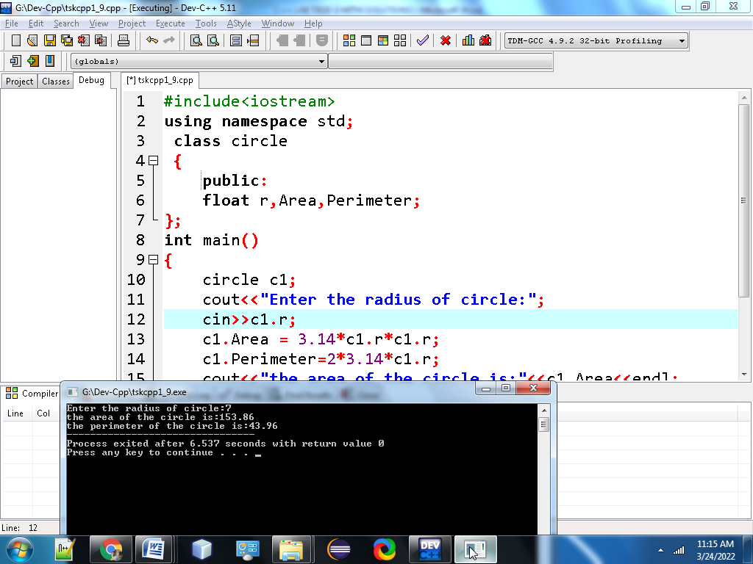

**10. Write a C program that takes three numbers as input to calculate and print the average of the numbers?**

**#include<iostream>**

**using namespace std;**

**class num**

**{**

**public:**

**int s1,s2,s3;**

**float sum, avg;**

**};**

**int main()**

**{**

**num n1;**

**cout<<"Enter The Value of s1 is:";**

**cin>>n1.s1;**

**cout<<"Enter The Value of s2 is:";**

**cin>>n1.s2;**

**cout<<"Enter The Value of s3 is:";**

**cin>>n1.s3;**

**n1.sum=n1.s1+n1.s2+n1.s3;**

**cout<<"The Sum of Three Numbers is:"<<n1.sum<<endl;**

**n1.avg=n1.sum/3;**

**cout<<"The Average of Three Numbers is:"<<n1.avg;**

**return 0;**

**}**

**Output:** 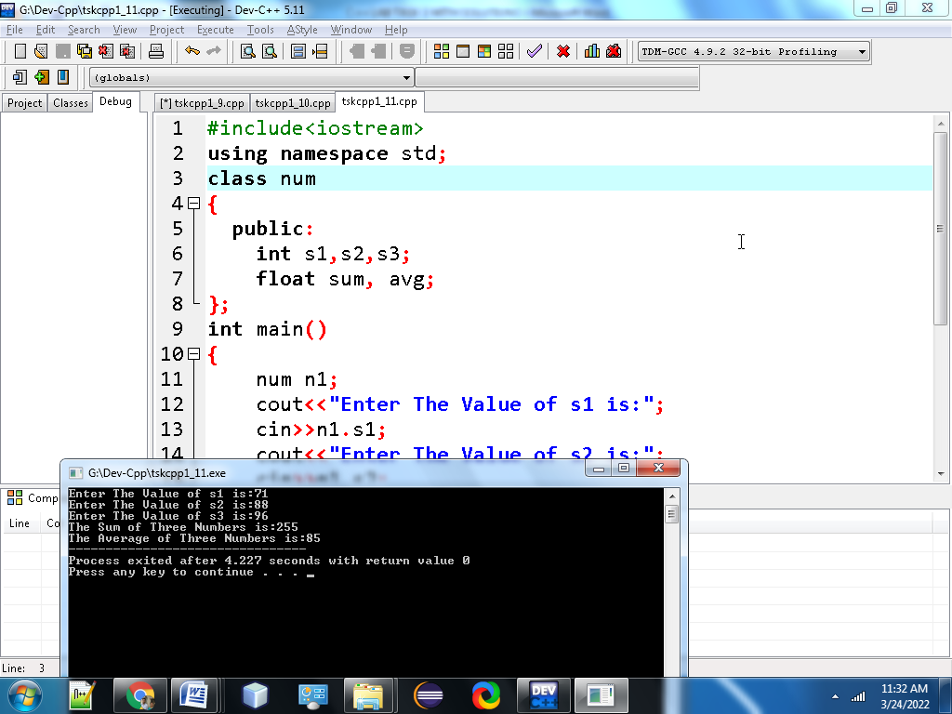

**11. Write a C program to swap two variables?**

**#include<iostream>**

**using namespace std;**

**class sp**

**{**

**public:**

**int first,second,temp;**

**};**

**int main()**

**{**

**sp s1;**

**cout<<"Enter first number:";**

**cin>>s1.first;**

**cout<<"Enter Second number:";**

**cin>>s1.second;**

**s1.temp = s1.first;**

**s1.first = s1.second;**

**s1.second =s1.temp;**

**cout<<"\nAfter swapping, first number="<<s1.first<<endl;**

**cout<<"After swapping, second number ="<<s1.second;**

**return 0;**

**}**

**Output:**

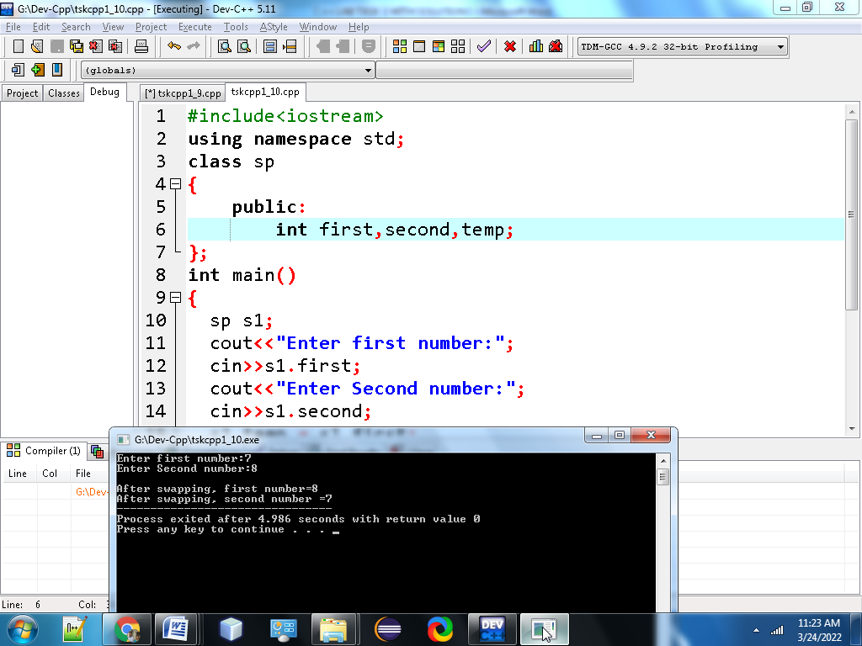

**12. Write a C program to convert a decimal number to binary number?**

**#include <iostream>**

**using namespace std;**

**class bin**

**{**

**public:**

**int a[10], number, i, j;**

**};**

**int main()**

**{**

**bin b1;**

**cout<<"\n Please Enter the Number You want to Convert:";**

**cin>>b1.number;**

**for(b1.i = 0; b1.number > 0; b1.i++)**

**{**

**b1.a[b1.i] =b1.number % 2;**

**b1.number =b1.number / 2;**

**}**

**cout<<"\n Binary Number of a Given Number=";**

**for(b1.j =b1.i - 1; b1.j >= 0; b1.j--) {**

**printf(" %d ", b1.a[b1.j]);**

**}**

**cout<<endl;**

**return 0;**

**}**

**Output:**

